**Materials and sensors used during our IoT project:**

**1.Bin**

Used to segregate in between plastic and metal objects.

**2. Load Sensor**

Load Sensors have been used to get the weight of the bin to provide data to the dashboard to give indications for the drivers when a bin is full or not.

**3. Separator**

A separator stand has been used to separate metal and plastic material into different sections of the bin.

**4. Jumper wire**

Connects two points in a circuit

**5. Servo Motor**

The servo motor will work in line with the proximity sensor to redirect the added material to its corresponding section with a sequence of rotation.

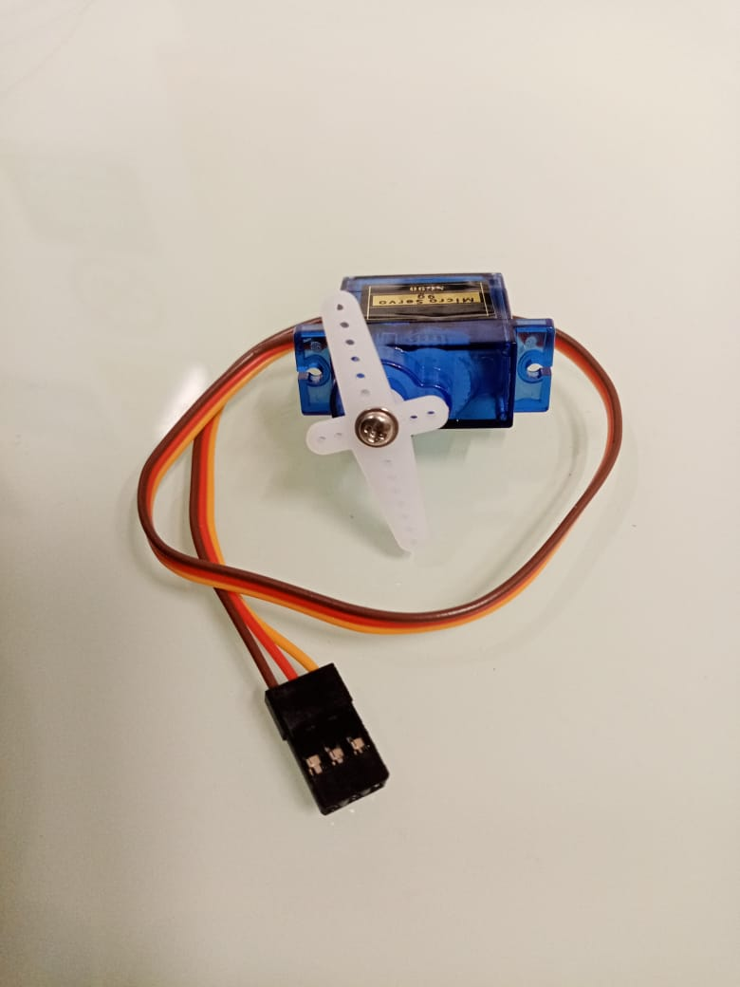

**6. Ultra-Sonic sensor**

Used to detect the presence of an object when entering the bin, it works along with the inductive proximity sensor when metal objects are detected, and vice versa

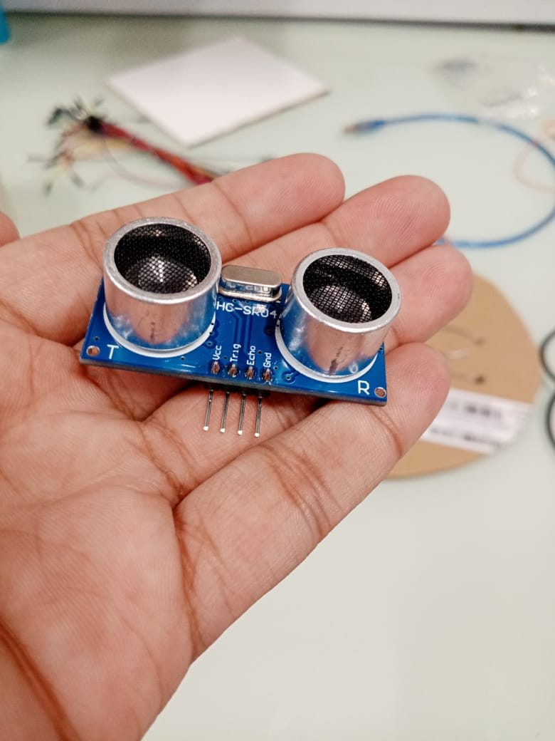 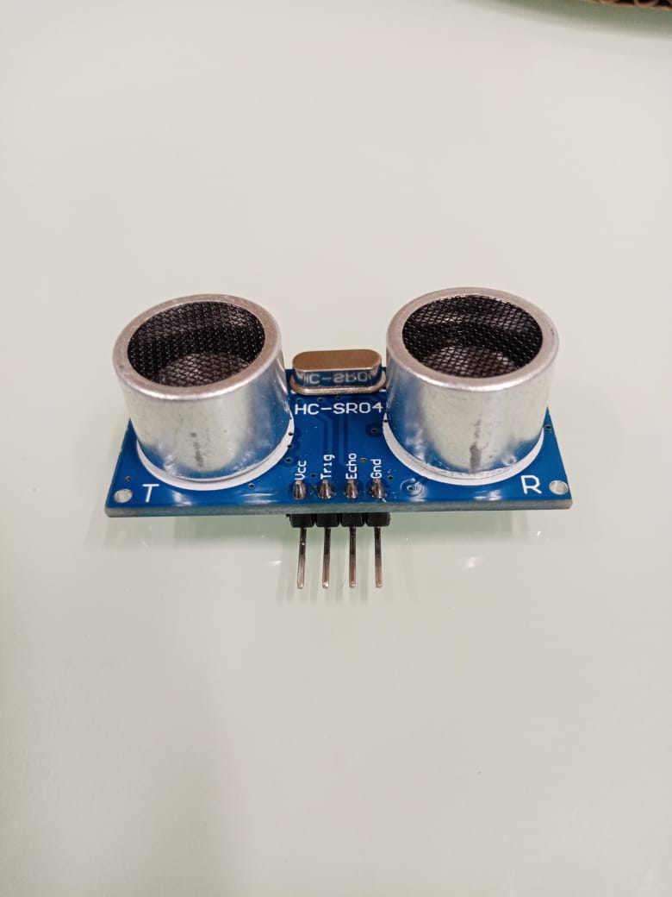

**7. Inductive Proximity sensor**

Used for the detection of metallic objects and separation of non-metallic objects.

**8. LED Lights**

Color led lights have been used to provide indications when the bin is empty, full which is a red light, or half full which is green light

Will be placed in front of the bin for easy visibility and uses.

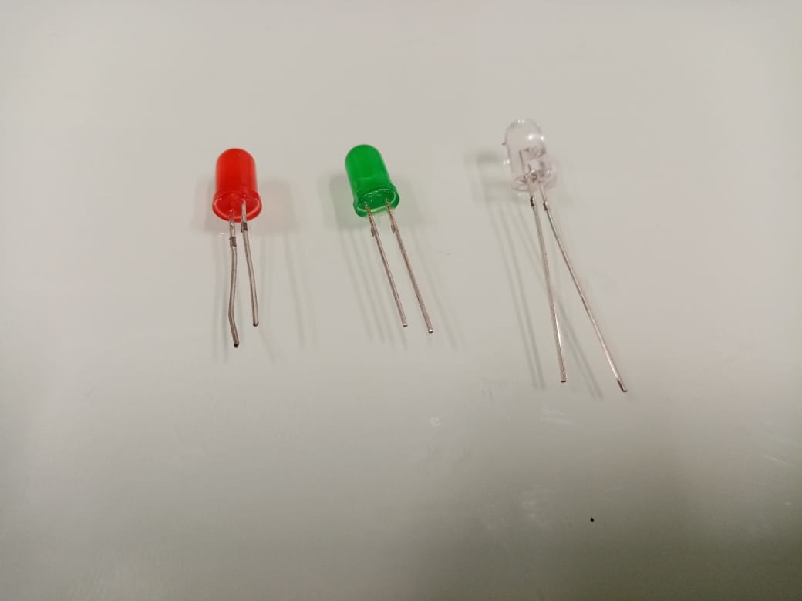

**9. Arduino Uno**

The mainboard that we used to connect our circuits and equipment (Much cheaper than the raspberry pie board)

**10. Amplifier**

**11. Blink app**

We have used blink as our dashboard where the weight will be displayed and monitored.

**12. Soldering Process**

13. Earth Day 22 April 2022

Our team has organized Green Campaign to raise awareness during Earth Day 2022 about recycling and segregation bin usage across Mauritius. We have done some demo testing. This session was very interactive where Parents and students were amazed by our prototype and have given us good feedback. They were given the opportunity to do testing and ask questions. We are now preparing for our 3 green campaign awareness by next month such that Mauritian people can be well informed and cultivate this culture in their daily life in order for having a green Mauritius.

**14. Testing of prototype**

**YouTube Link:** [**https://youtube.com/shorts/JbdpgBiXSBs?feature=share**](https://youtube.com/shorts/JbdpgBiXSBs?feature=share)

**15. Working Process**

